Jira Hands-On Practice: Cloud Database Migration Project

Introduction
Jira is a project management tool used to plan, track and manage tasks in software development projects.
In this practice, I created a Scrum project named Cloud Database Migration and worked with Epics, User Stories, Tasks, Sub-tasks, Sprints and Issue Linking.

Creating a Scrum Project
I created a new Scrum project in Jira with the following details:
  - Project Name: Cloud Database Migration
  - Project Key: CDM
  - Project Type: Scrum
A Scrum project helps organize work into manageable tasks and sprints.
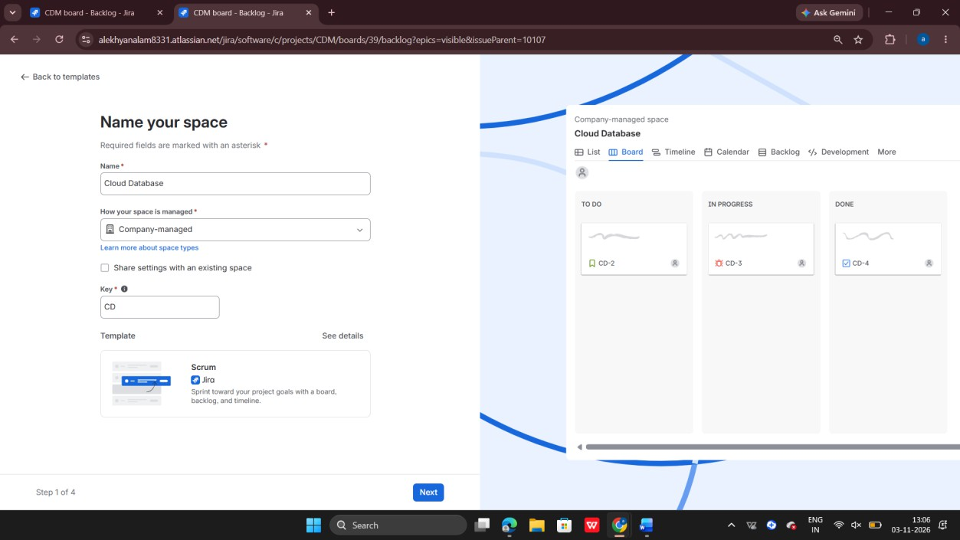

Creating an Epic
An Epic is a large body of work that can be divided into smaller User Stories and Tasks. I created the following Epic:
  - Epic Name: Cloud Database Migration
  - Issue Key: CDM-1

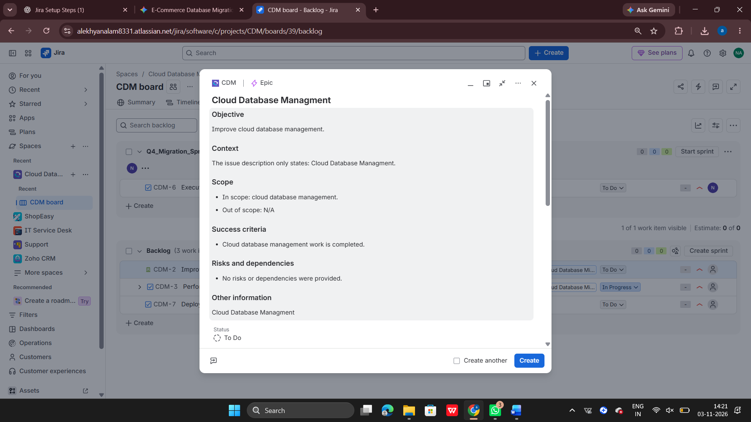

Creating a User Story
A User Story describes a requirement from the customer's point of view. I created the following User Story:
  - Summary: Improve checkout page load time
  - Description: As a customer, I want faster page load times during checkout so that I can complete my purchase quickly.
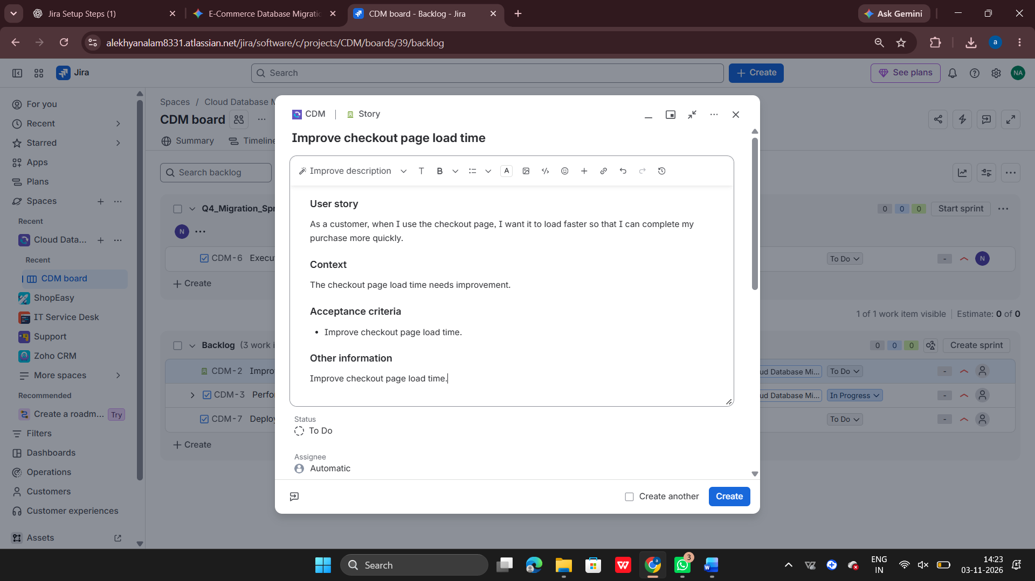

Creating Tasks
I created a technical task under the project:

  - Task Name: Performance benchmark testing for AWS Aurora instance This task focuses on checking the performance of the AWS Aurora database.
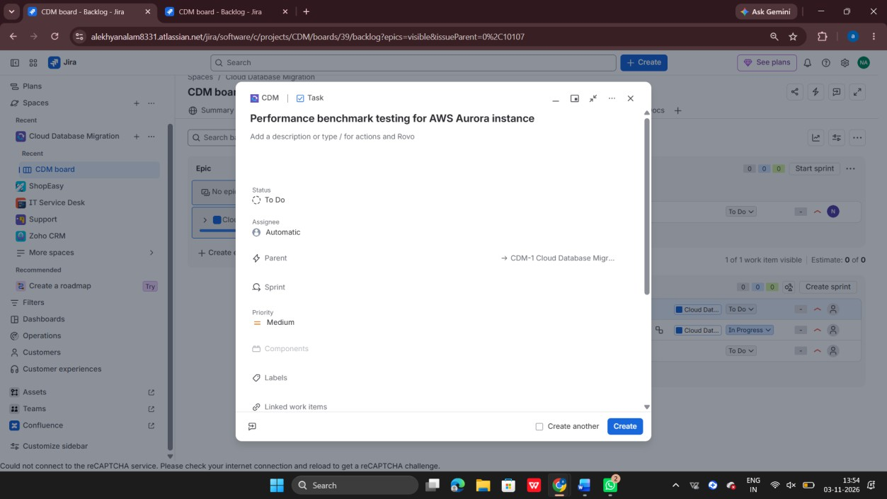

Creating Sub-tasks
Sub-tasks help divide a main task into smaller activities. I created two sub-tasks:
- Write automated load-testing scripts.
- Execute 10,000 concurrent user simulation.
These sub-tasks help organize the performance testing activities.

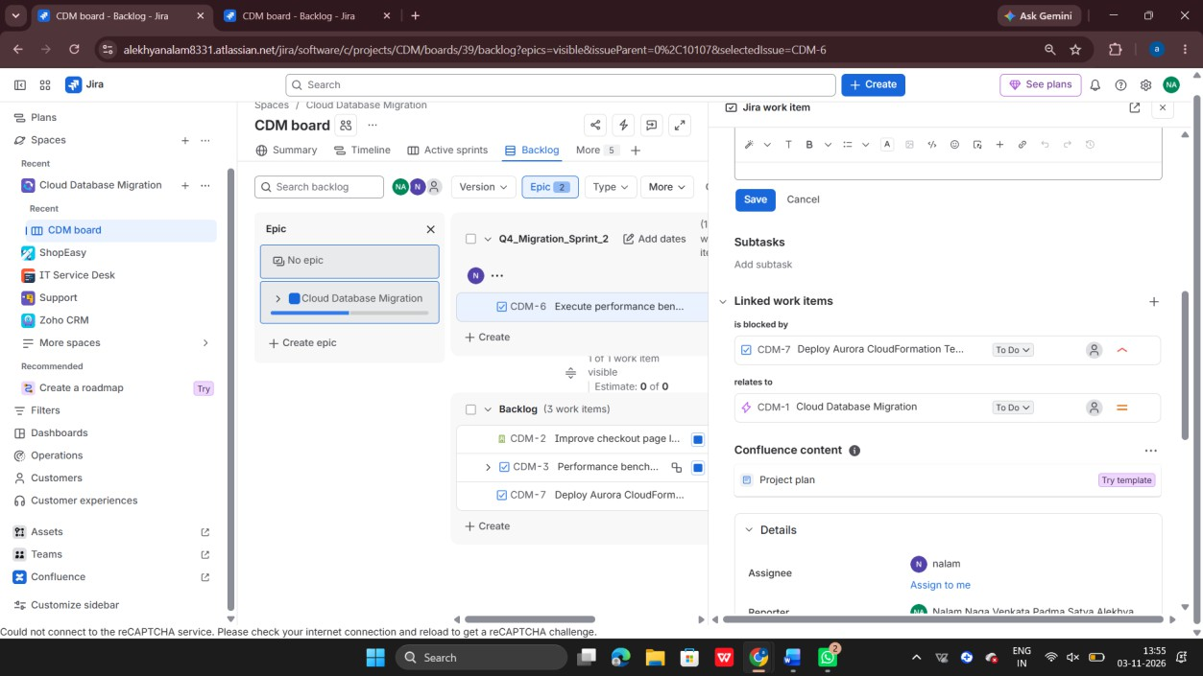

Creating a Real-World Task
I created another task based on a real-world database migration scenario.
  - Task Name: Execute performance benchmarking on AWS Aurora staging database
  - Issue Key: CDM-6
  - Priority: High
Objective: Validate whether the AWS Aurora staging database can handle high traffic before production migration.

Scope of Work:
  - Prepare an Aurora staging environment.
  - Run load-testing activities.
  - Capture CPU utilization, IOPS and query latency.

Definition of Done:
  - Complete the planned performance test.
  - Prepare and attach the performance report.
  - Check whether query latency is below 200 ms.

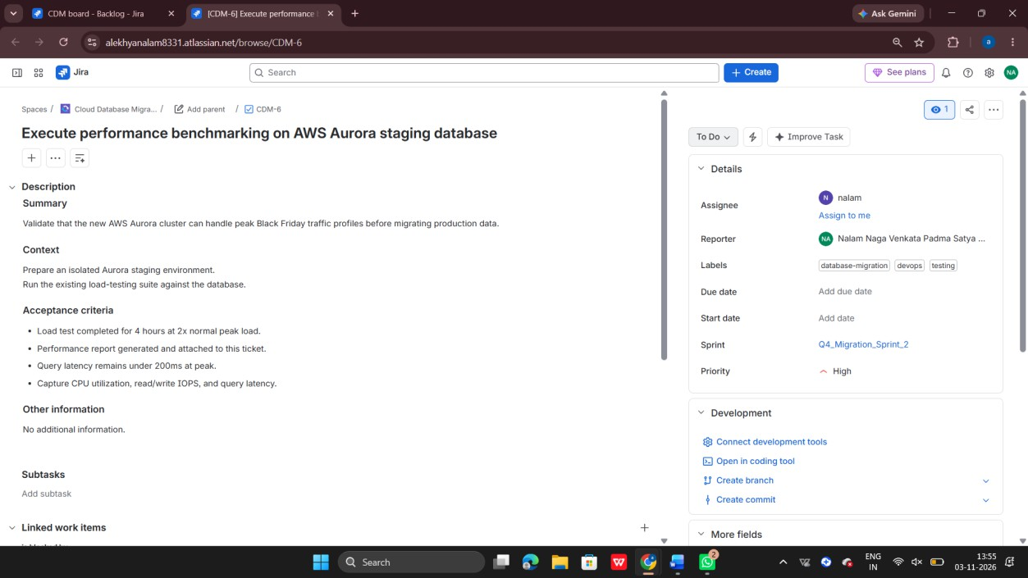

Adding Labels and Assignee
I added labels to identify and categorize the task. Labels added:
  - devops
  - database-migration
  - testing
I also assigned the task to an available Jira user.
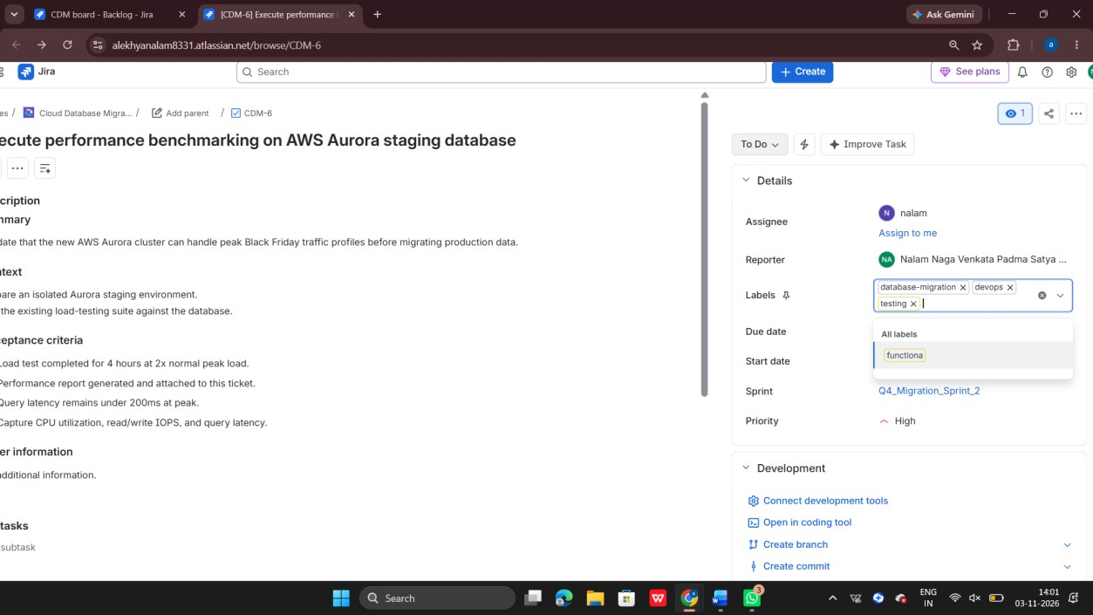

Sprint Management
A Sprint is a fixed period during which a team works to complete selected tasks. I created a sprint named:
  - Sprint Name: Q4_Migration_Sprint_2
I added the performance benchmarking task (CDM-6) to this sprint.

Creating a Supporting Task
I created another task to represent the supporting database deployment activity.
  - Task Name: Deploy Aurora CloudFormation Templates
  - Issue Key: CDM-7
This task represents the infrastructure preparation activity required for the database migration.

Linking Issues and Managing Dependencies
Issue Linking helps identify relationships and dependencies between Jira issues. I linked the issues as follows:
  - CDM-6 is blocked by CDM-7.
  - CDM-6 relates to CDM-1.
This helps track dependencies between project activities.

Understanding the Jira Issue Hierarchy
The project contains different types of issues:
  - Epic – Cloud Database Migration
  - User Story – Improve checkout page load time
  - Task – Performance benchmark testing for AWS Aurora instance
  - Sub-tasks – Load-testing script creation and concurrent user simulation This structure helps organize project requirements and technical activities.

Best Practices Learned
  - Create clear and meaningful issue summaries.
  - Divide large tasks into smaller sub-tasks.
  - Use labels to categorize issues.
  - Assign tasks to appropriate team members.

  - Organize work using sprints.
  - Link related issues to track dependencies.
  - Keep task descriptions and status updated.

Learning Outcomes
After completing this hands-on practice, I learned how to:
  - Create a Scrum project in Jira.
  - Create and manage Epics and User Stories.
  - Create Tasks and Sub-tasks.
  - Add task descriptions, labels and assignees.
  - Create a sprint and add issues to it.
  - Create supporting tasks.
  - Link issues using dependency relationships.
  - Understand Jira project organization and task management.

Conclusion
Through this hands-on practice, I gained practical experience in Jira project management using the Cloud Database Migration project.
I learned how to organize project work, create and manage different issue types, plan sprint activities and track dependencies using issue linking.

